Business Report — HR Employee Attrition Prediction
AnalystLab Africa Machine Learning Internship — Week 3
Project objective: develop and evaluate supervised classification models capable of predicting employee attrition from the Week 2 machine-learning-ready HR dataset.

1. Modelling Approach
The Week 2 final ML-ready dataset contains 1,470 employee records and 31 predictor variables plus the binary Attrition target. The supplied Week 2 training file contains 1,176 records. The remaining 294 records were treated as the unseen hold-out test set, producing an 80/20 train/test arrangement.
The target is imbalanced: approximately 83.9% of observations are non-attrition and 16.1% are attrition. To reduce the risk of a model simply favouring the majority class, class balancing was applied through balanced class weights for Logistic Regression, Decision Tree and Random Forest, and a positive-class weight for XGBoost.

2. Algorithms Selected
- Logistic Regression — interpretable linear baseline and strong choice when explainability is important.
- Decision Tree — captures nonlinear relationships and produces an intuitive rule-based structure.
- Random Forest — ensemble of trees designed to improve stability and capture nonlinear interactions.
- XGBoost — gradient-boosted decision trees capable of modelling complex nonlinear patterns.

3. Evaluation Results
Model | Accuracy | Precision | Recall | F1 Score | ROC-AUC
Logistic Regression | 0.7381 | 0.3500 | 0.7447 | 0.4762 | 0.8101
Random Forest | 0.8265 | 0.4167 | 0.2128 | 0.2817 | 0.7684
XGBoost | 0.8027 | 0.3878 | 0.4043 | 0.3958 | 0.7533
Decision Tree | 0.6803 | 0.2235 | 0.4043 | 0.2879 | 0.5654
The models were evaluated using Accuracy, Precision, Recall, F1 Score and ROC-AUC, as required by the assignment. The highest ROC-AUC was obtained by Logistic Regression (0.810), while the same model achieved recall of 0.745.

4. Model Comparison
Logistic Regression produced the strongest overall discrimination on the supplied hold-out set. It also achieved the highest recall, which is important in an attrition setting because a false negative represents an employee who may leave but is not flagged for intervention.
The Decision Tree was the weakest model by ROC-AUC in this evaluation. Random Forest achieved higher accuracy than Logistic Regression but substantially lower recall. XGBoost provided intermediate results. These results show why comparing multiple algorithms is preferable to selecting a model based on a single metric.

5. Feature Importance
Permutation importance was used for the selected Logistic Regression model. This measures how much predictive performance decreases when a feature's values are randomly permuted. The result should be interpreted as predictive contribution rather than causal evidence.
Feature | Importance
MonthlyIncome | 0.06178
OverTime_Yes | 0.04174
OverTimeIndicator | 0.04174
YearsSincePromotion | 0.03518
MaritalStatus_Single | 0.01503
StockOptionLevel | 0.01190
JobInvolvement | 0.01169
NumberOfCompaniesWorked | 0.00970
YearsWithCompany | 0.00826
DistanceFromHome | 0.00596
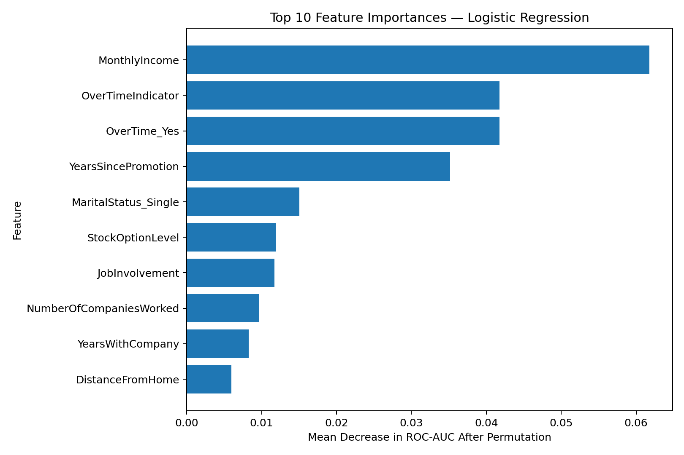

6. Business Recommendations
- Use the recommended model as a decision-support tool for identifying employees who may require retention attention.
- Prioritise high-risk cases for human review rather than treating a prediction as a definitive statement about an employee.
- Monitor overtime, compensation, promotion history, job involvement, stock-option level and other leading predictive variables identified by the model as part of broader HR analytics.
- Use recall and ROC-AUC alongside precision when assessing the model because attrition is an imbalanced outcome and missed at-risk employees can be costly.
- Reassess the model periodically as workforce conditions, policies and employee behaviour change.

7. Next Steps
- Validate the model on a future time-based employee cohort before production deployment.
- Perform threshold tuning with HR stakeholders using explicit costs for false positives and false negatives.
- Calibrate predicted probabilities if the business needs reliable risk probabilities.
- Monitor model drift, fairness and performance after deployment.
- Conduct further hyperparameter tuning and cross-validation before production release.

Conclusion
Based on the supplied Week 2 data and the hold-out evaluation, Logistic Regression is the recommended model. It achieved ROC-AUC of 0.810 and recall of 0.745. The recommendation is supported by objective evaluation rather than by model popularity or complexity.

